OUTPUT:
Challenge 1
Downloading data for ['AAPL', 'MSFT', 'GOOG', 'AMZN', 'NVDA'] from 2020-01-01 to 2025-06-16...
<ipython-input-1-1936261411>:16: FutureWarning: YF.download() has changed argument auto_adjust default to True
data = yf.download(tickers, start=start_date, end=end_date, progress=False)
Error downloading data: 'Adj Close'
Falling back to dummy data for demonstration.
Using dummy data for demonstration.
Sample of dummy daily returns:
AAPL MSFT GOOG AMZN NVDA
2020-01-01 0.004967 -0.001383 0.006477 0.015230 -0.002342
2020-01-02 -0.002341 0.015792 0.007674 -0.004695 0.005426
2020-01-03 -0.004634 -0.004657 0.002420 -0.019133 -0.017249
2020-01-06 -0.005623 -0.010128 0.003142 -0.009080 -0.014123
2020-01-07 0.014656 -0.002258 0.000675 -0.014247 -0.005444
Original Data Shape: (250, 5)

Sample of Scaled Returns:
AAPL MSFT GOOG AMZN NVDA
2020-01-01 0.511921 -0.093822 0.667288 1.478569 -0.343482
2020-01-02 -0.269829 1.568362 0.791827 -0.572084 0.411382
2020-01-03 -0.515078 -0.410745 0.245321 -2.058026 -1.792310
2020-01-06 -0.620833 -0.940233 0.320499 -1.023432 -1.488490
2020-01-07 1.548335 -0.178517 0.063904 -1.555236 -0.644984

Extracted Principal Components (First 2 components):
PC_1 PC_2
2020-01-01 -0.031339 -1.097103
2020-01-02 1.123514 1.237196
2020-01-03 -0.647951 0.130088
2020-01-06 -0.860641 -0.401091
2020-01-07 0.635569 -0.745915
New Data Shape (after PCA with 2 components): (250, 2)

Explained Variance Ratio for each Principal Component:
PC_1: 0.2322 (23.22%)
PC_2: 0.2169 (21.69%)
Cumulative explained variance by 2 components: 0.4490

Principal Component Loadings (how original features contribute to PCs):
AAPL MSFT GOOG AMZN NVDA
PC_1 0.384230 0.218025 0.60742 -0.275103 0.600159
PC_2 -0.596389 0.633327 -0.26401 -0.312089 0.275891
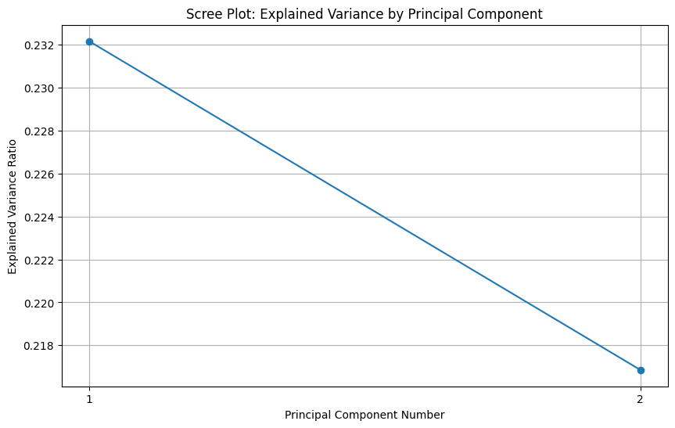
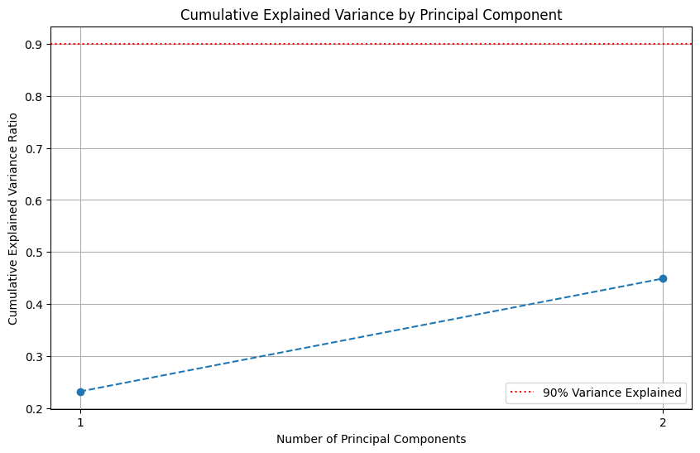
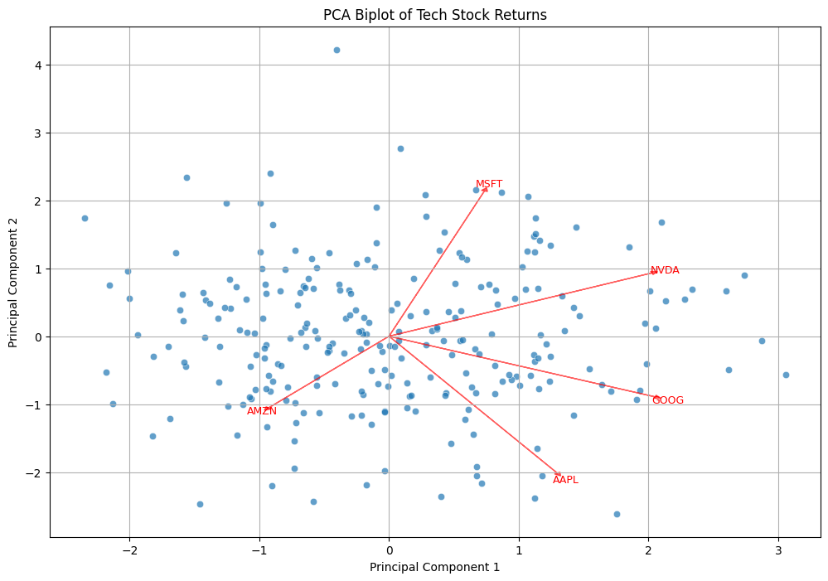
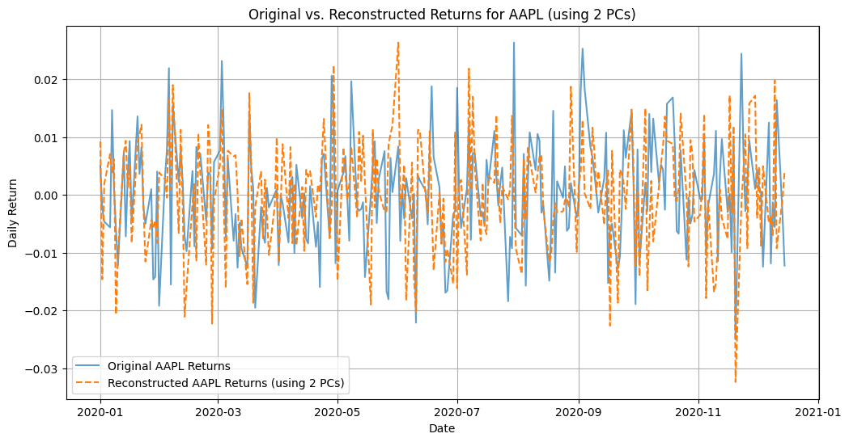

Mean Squared Error of Reconstruction for each feature:
9.660822565600153e-05
Average MSE across all features: 0.000097

Challenge 3
Downloading data for ['^GSPC', '^IXIC', '^DJI', '^RUT'] from 2020-01-01 to 2025-06-16...
<ipython-input-3-1663625532>:20: FutureWarning: YF.download() has changed argument auto_adjust default to True
data_multi = yf.download(tickers_multi, start=start_date_multi, end=end_date_multi, progress=False)
Error downloading data: 'Adj Close'
Falling back to dummy data for demonstration.
Using dummy data with multicollinearity for demonstration.
Sample of dummy index prices:
^GSPC ^IXIC ^DJI ^RUT
2020-01-01 999.624693 1199.782640 899.972003 800.464232
2020-01-02 1000.282871 1199.743293 899.685211 800.261149
2020-01-03 1000.905941 1199.804937 899.288441 799.992357
2020-01-06 1000.103483 1199.371925 899.163462 800.056759
2020-01-07 999.369412 1198.556892 899.212487 800.099779

--- OLS Regression Results (Potentially Affected by Multicollinearity) ---
OLS Regression Results
==============================================================================
Dep. Variable: Target_RUT_NextDay R-squared: 0.013
Model: OLS Adj. R-squared: 0.001
Method: Least Squares F-statistic: 1.105
Date: Tue, 17 Jun 2025 Prob (F-statistic): 0.348
Time: 14:37:40 Log-Likelihood: 1609.4
No. Observations: 248 AIC: -3211.
Df Residuals: 244 BIC: -3197.
Df Model: 3
Covariance Type: nonrobust
==============================================================================
coef std err t P>|t| [0.025 0.975]
------------------------------------------------------------------------------
const -4.377e-05 2.37e-05 -1.844 0.066 -9.05e-05 2.98e-06
^GSPC -0.0540 0.046 -1.168 0.244 -0.145 0.037
^IXIC 0.0578 0.049 1.185 0.237 -0.038 0.154
^DJI -0.0516 0.052 -0.985 0.326 -0.155 0.052
==============================================================================
Omnibus: 2.285 Durbin-Watson: 2.072
Prob(Omnibus): 0.319 Jarque-Bera (JB): 2.275
Skew: 0.231 Prob(JB): 0.321
Kurtosis: 2.921 Cond. No. 2.27e+03
==============================================================================

Notes:
[1] Standard Errors assume that the covariance matrix of the errors is correctly specified.
[2] The condition number is large, 2.27e+03. This might indicate that there are
strong multicollinearity or other numerical problems.

--- Variance Inflation Factors (VIF) Scores ---
feature VIF
0 ^GSPC 1.007030
1 ^IXIC 1.009335
2 ^DJI 1.006176

--- Ridge Regression Results (Handling Multicollinearity) ---

Ridge Regression with alpha = 0.1
Coefficients (on scaled data):
^GSPC: -0.0000
^IXIC: 0.0000
^DJI: -0.0000
Intercept (on scaled data): -0.0001
RMSE on Test Set: 0.0003

Ridge Regression with alpha = 1.0
Coefficients (on scaled data):
^GSPC: -0.0000
^IXIC: 0.0000
^DJI: -0.0000
Intercept (on scaled data): -0.0001
RMSE on Test Set: 0.0003

Ridge Regression with alpha = 10.0
Coefficients (on scaled data):
^GSPC: -0.0000
^IXIC: 0.0000
^DJI: -0.0000
Intercept (on scaled data): -0.0001
RMSE on Test Set: 0.0003
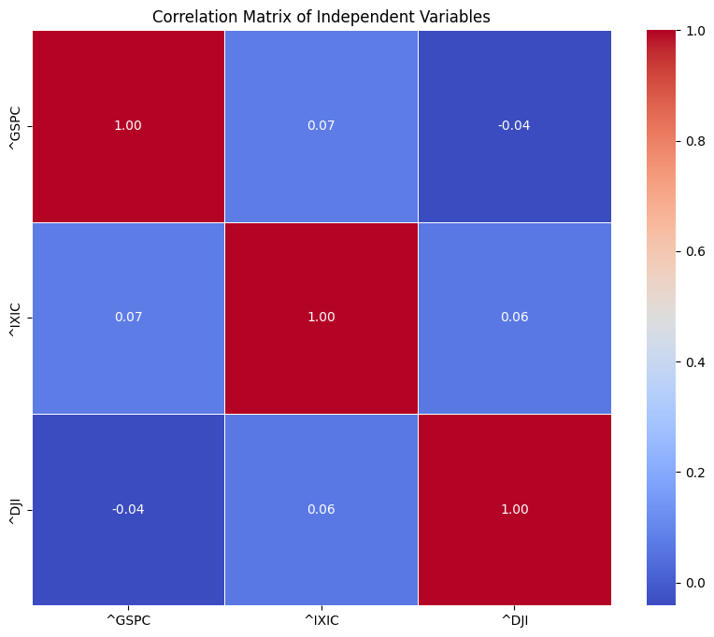
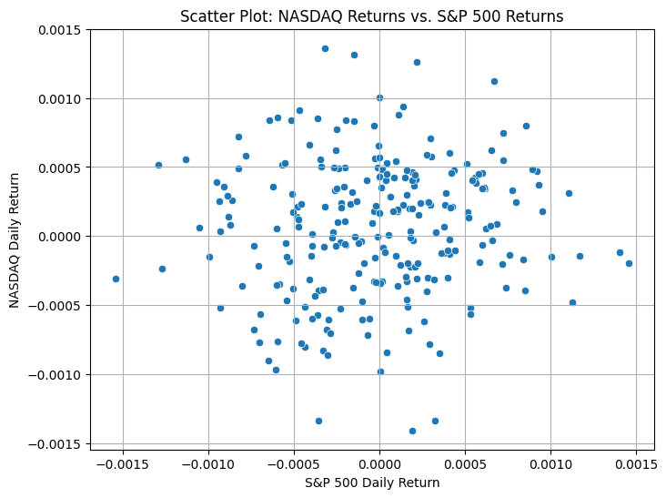
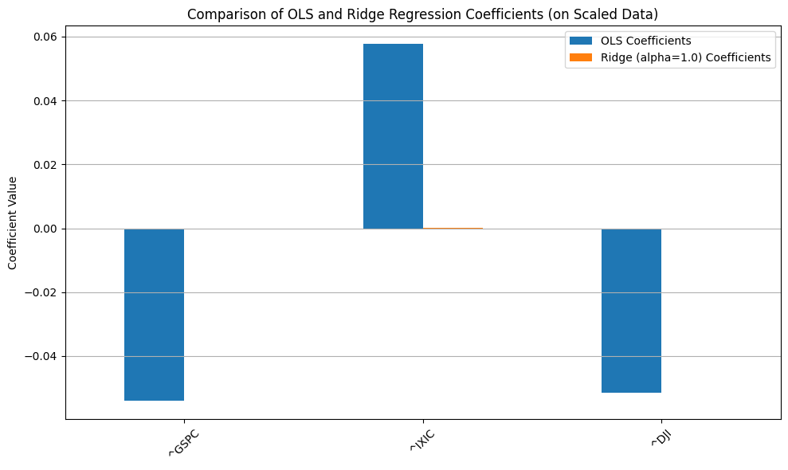
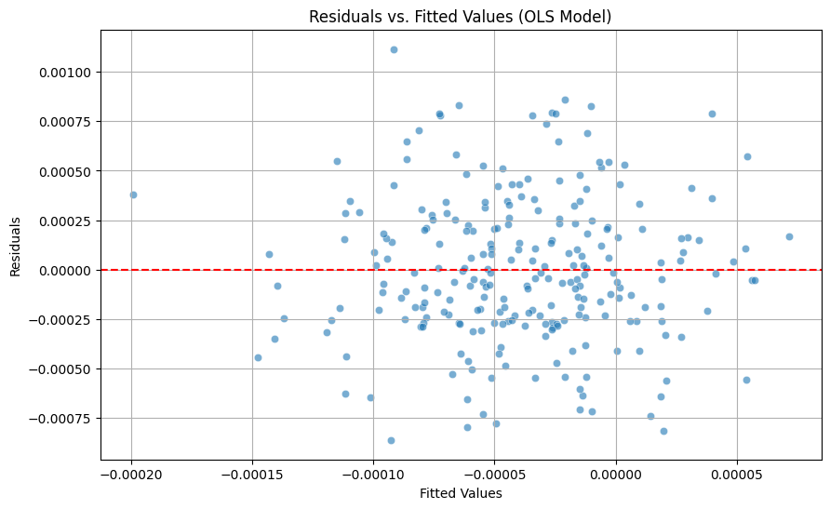
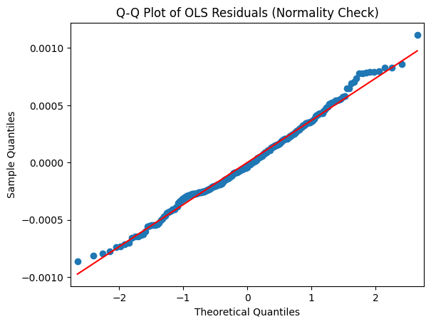

RMSE on Test Set (OLS Model): 0.0003
RMSE on Test Set (Ridge Model with alpha=1.0): 0.0003
Conclusion: Ridge regression improved out-of-sample performance (lower RMSE).

